Normality Checking

Multivariate Normality:

In this case, we assume $Σ_{1}=Σ_{2}=Σ_{3}=Σ_{4}$**.**

For Group 1: For Group 2:

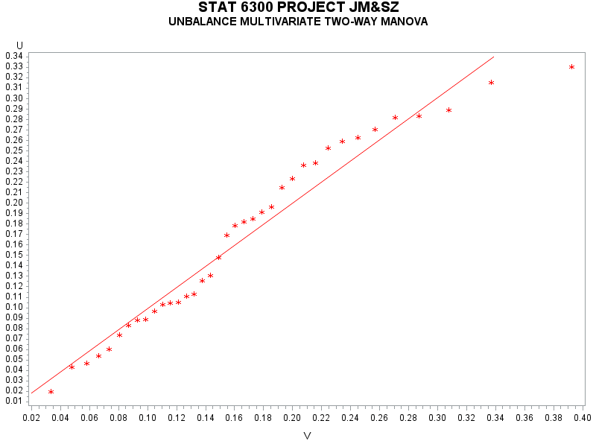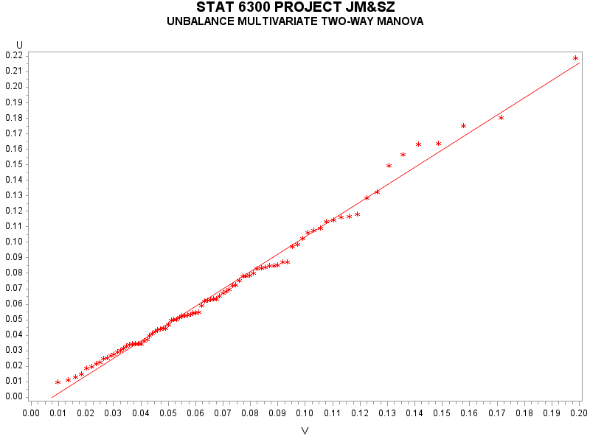

For Group 3 For Group 4:

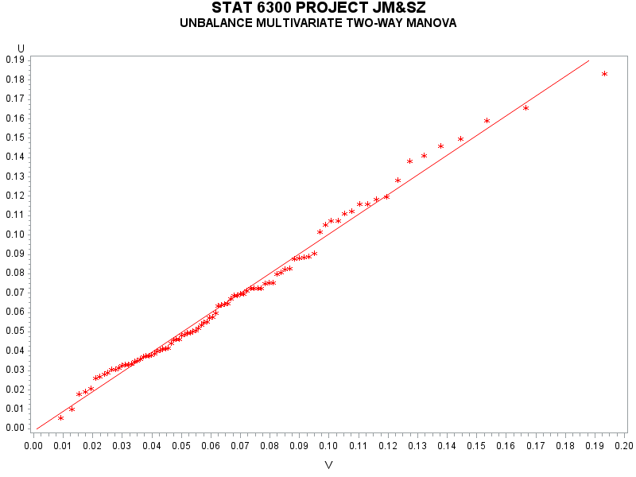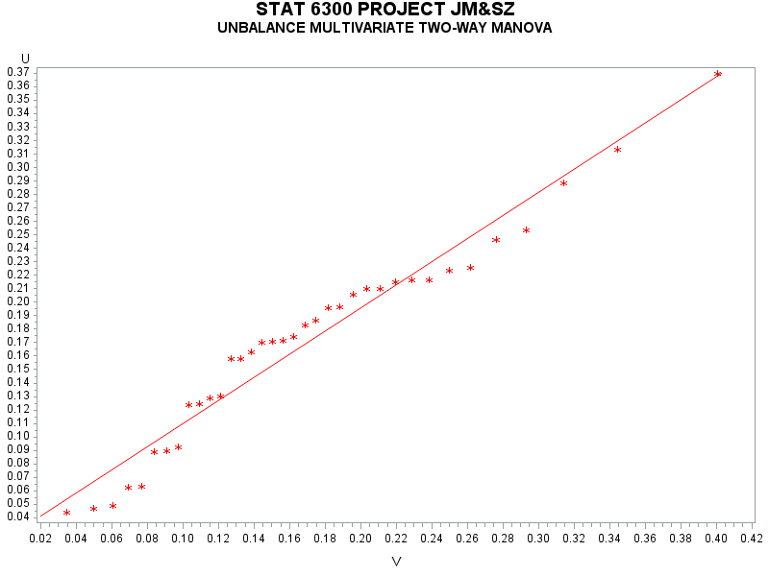

|  |  |  |
| --- | --- | --- |
| Group | T.S. | R.R. |
| age<30 | 11.5839 | Reject $H_{0}$ if $D_{i}^{2}$ > 23.094 |
| 30 $≤$ age<40 | 18.6273 | Reject $H_{0}$ if $D_{i}^{2}$ > 19.197 |
| 40 $≤$ age<50 | 16.1424 | Reject $H_{0}$ if $D_{i}^{2}$ > 19.197 |
| age $≥$ 50 | 12.5785 | Reject $H_{0}$ if $D_{i}^{2}$ > 23.094 |

Conclusion:

With $p=6,n_{1}=37$ and $α=0.01$, the critical value is $23.094$. Since the max $D_{i}^{2}=11.5839<23.094$, there is sufficient evidence that the data for group 1 (age<30) are multivariate normal.

With $p=6,n_{1}=37$ and $α=0.01$, the critical value is $23.094$. Since the max $D_{i}^{2}=18.6273<19.197$, there is sufficient evidence that the data for group 2 (30 $≤$ age<40) are multivariate normal.

With $p=6,n_{1}=37$ and $α=0.01$, the critical value is $23.094$. Since the max $D_{i}^{2}=16.1424<19.197$, there is sufficient evidence that the data for group 3 (40 $≤$ age<50) are multivariate normal.

With $p=6,n_{1}=376$ and $α=0.01$, the critical value is $23.094$. Since the max $D_{i}^{2}=12.5785<23.094$, there is sufficient evidence that the data for group 4 (age $≥$ 50) are multivariate normal.

Since the data for each group is multivariate normal, we do not need to check normality for individual variable within each group.

From Table A.6, with $p=6,n=250$ and $α=0.05$, the critical value is $13.202$. Since the max $D_{i}^{2}=21.16128>13.202$, there is sufficient evidence that the data are not multivariate normal.



From this Q-Q plot, it does not look like the plot is a straight line especially for those points which V values are larger. There is some indication that the data are not multivariate normal.

Univariate Normality:

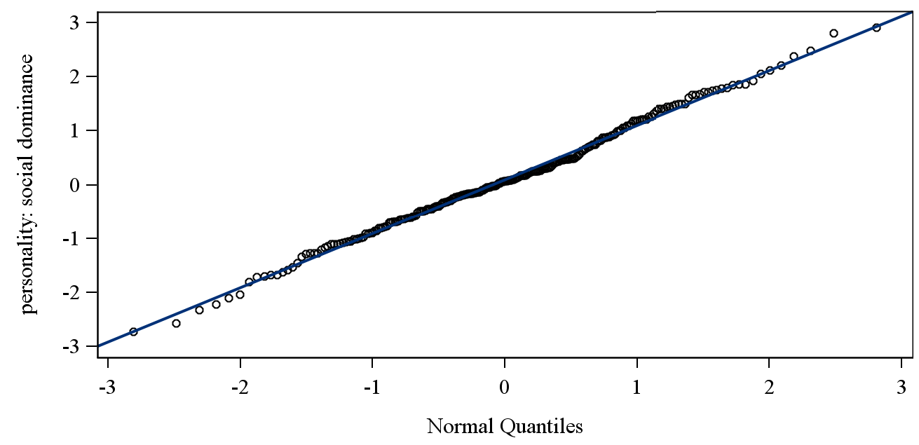

This looks like a fairly straight line, and it appears that $y_{1}$ =social dominance is univariate normal.

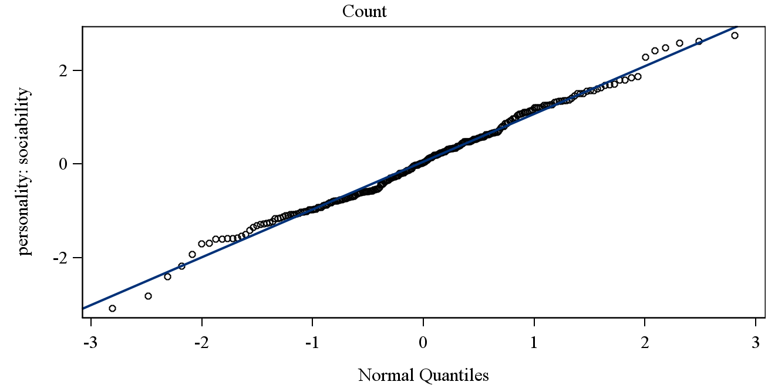

This looks like a fairly straight line, and it appears that $y_{2}$ =sociability is univariate normal.

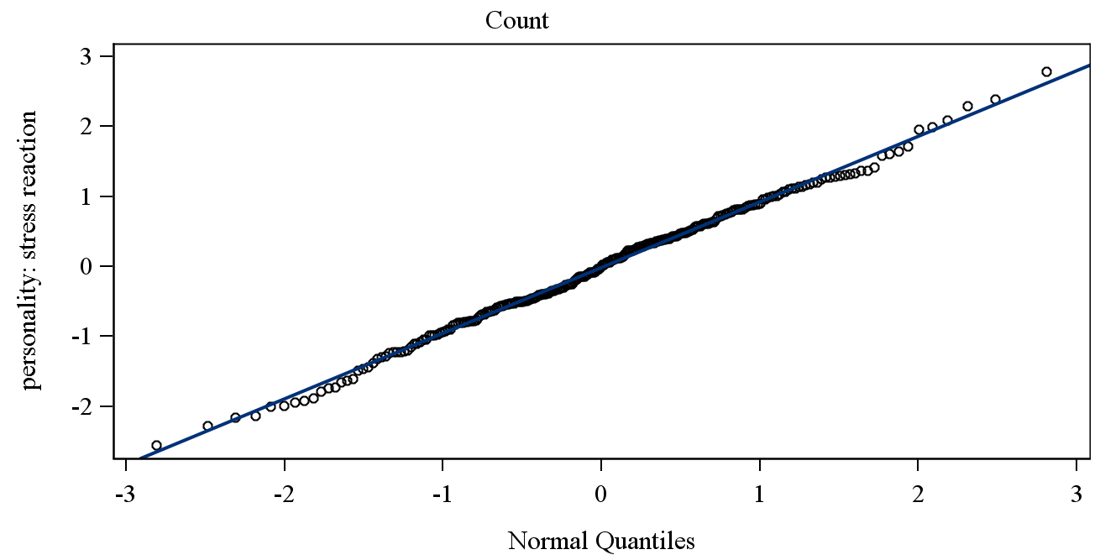

This looks like a fairly straight line, and it appears that $y_{3}$ =stress reaction is univariate normal.

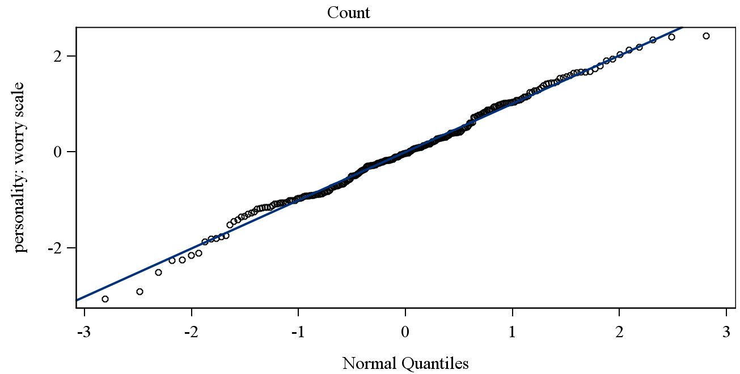

This looks like a fairly straight line, and it appears that $y_{4}$ =worry scale is univariate normal.

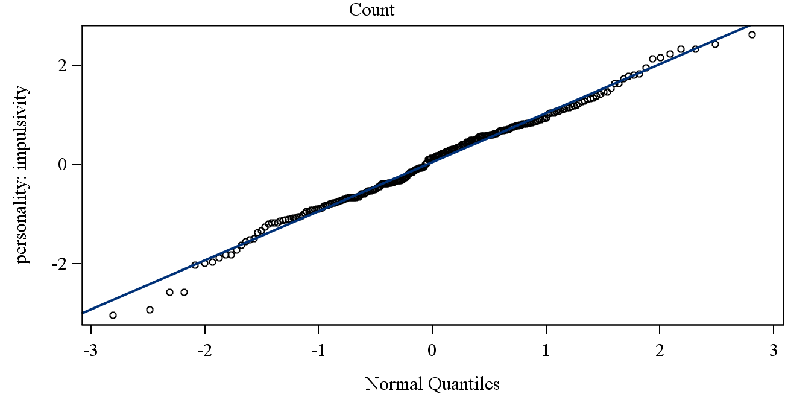

This looks like a fairly straight line, and it appears that $y_{5}$ =impulsivity is univariate normal.

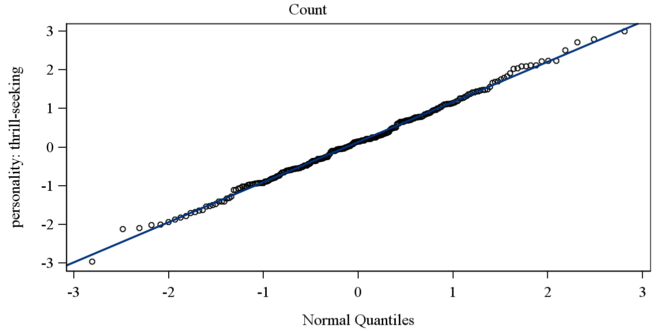

This looks like a fairly straight line, and it appears that $y_{6}$ =thrill seeking is univariate normal.

|  |  |  |
| --- | --- | --- |
| Variable | W | p-value |
| $$y_{1}$$ | 0.995829 | 0.7419 |
| $$y_{2}$$ | 0.992698 | 0.2567 |
| $$y_{3}$$ | 0.996561 | 0.8639 |
| $$y_{4}$$ | 0.993132 | 0.3047 |
| $$y_{5}$$ | 0.992082 | 0.1999 |
| $$y_{6}$$ | 0.997212 | 0.9437 |

Using the Shapiro-Wilk test, there is insufficient evidence that all the variables are not normal at $α=0.05$.

One-way ANOVA

Multivariate Test:

| **Characteristic Roots and Vectors of: E Inverse * H, where H = Type III SSCP Matrix for GRP E = Error SSCP Matrix** | | | | | | | |
| --- | --- | --- | --- | --- | --- | --- | --- |
| **Characteristic Root** | **Percent** | **Characteristic Vector  V'EV=1** | | | | | |
| **socdom** | **sociabty** | **stress** | **worry** | **impulsve** | **thrillsk** |
| **0.09702180** | 77.86 | 0.03045661 | 0.01974062 | -0.00980927 | 0.00457444 | 0.03210055 | 0.01967837 |
| **0.01726020** | 13.85 | 0.01188722 | 0.01913020 | 0.04401496 | -0.02444126 | -0.05391818 | 0.03643940 |
| **0.01032065** | 8.28 | -0.04418056 | 0.04979508 | 0.04485475 | -0.01080491 | 0.03175540 | -0.03002987 |
| **0.00000000** | 0.00 | -0.00094640 | 0.01369070 | -0.01651820 | 0.06630678 | -0.01404024 | 0.00864480 |
| **0.00000000** | 0.00 | 0.04108946 | -0.05038994 | 0.04004474 | 0.00126044 | 0.02333888 | -0.00708734 |
| **0.00000000** | 0.00 | -0.03830368 | 0.00019869 | 0.00842222 | 0.00587055 | -0.00123271 | 0.04882719 |

Since the first two explain 91.71% (=77.86+13.85) of the total sum, that is, the essential dimensionality of the space of the mean vector is 2. Therefore, I will choose Pillai’s Trace as the test statistics.

| **MANOVA Test Criteria and F Approximations for the Hypothesis of No Overall GRP Effect H = Type III SSCP Matrix for GRP E = Error SSCP Matrix S=3    M=1    N=119.5** | | | | | |
| --- | --- | --- | --- | --- | --- |
| **Statistic** | **Value** | **F Value** | **Num DF** | **Den DF** | **Pr > F** |
| **Wilks' Lambda** | 0.88693840 | 1.64 | 18 | 682.14 | 0.0451 |
| **Pillai's Trace** | 0.11562365 | 1.62 | 18 | 729 | 0.0488 |
| **Hotelling-Lawley Trace** | 0.12460265 | 1.66 | 18 | 476.03 | 0.0427 |
| **Roy's Greatest Root** | 0.09702180 | 3.93 | 6 | 243 | 0.0009 |
| **NOTE: F Statistic for Roy's Greatest Root is an upper bound.** | | | | | |

| **MANOVA Tests for the Hypothesis of No Overall GRP Effect H = Type III SSCP Matrix for GRP E = Error SSCP Matrix S=3    M=1    N=119.5** | | |
| --- | --- | --- |
| **Statistic** | **Value** | **P-Value** |
| **Wilks' Lambda** | 0.88693840 | 0.0451 |
| **Pillai's Trace** | 0.11562365 | 0.0478 |
| **Hotelling-Lawley Trace** | 0.12460265 | 0.0427 |
| **Roy's Greatest Root** | 0.09702180 | 0.0149 |

Assume $y_{ij}\sim N_{6}(μ_{i}, Σ)$, independent and random samples.

$H_{0}: μ_{1}=μ_{2}=μ_{3}=μ_{4}$ vs $H_{α}:$ at least 1 $μ_{i}$ differs

T.S. $V^{(3)}=0.11562365$

R.R. Reject $H_{0}$ if p-value < 0.05.

Conclusion: Reject $H_{0}$ at $α=0.05$. There is sufficient evidence of a difference in mean vector among the 4 groups of age.

Univariate Test:

For each variable, we test

$H_{0}: μ_{i1}=μ_{i2}=μ_{i3}=μ_{i4}$ vs $H_{α}:$ at least 1 $μ_{ij}$ differs

|  |  |  |  |
| --- | --- | --- | --- |
| Variable | T.S. | R.R. | Decision |
| $y_{1}$ = social dominance | F=3.46, p=0.0171 | Reject if $p<α=0.05$ | Reject $H_{0}$ |
| $y_{2}$ = sociability | F=3.15, p=0.0257 | Reject if $p<α=0.05$ | Reject $H_{0}$ |
| $y_{3}$ = stress reaction | F=0.71, p=0.5445 | Reject if $p<α=0.05$ | Do not Reject $H_{0}$ |
| $y_{4}$ =worry scale | F=0.09, p=0.965 | Reject if $p<α=0.05$ | Do not Reject $H_{0}$ |
| $y_{5}$ = impulsivity | F=3.86, p=0.01 | Reject if $p<α=0.05$ | Reject $H_{0}$ |
| $y_{6}$ =thrill seeking | F=2.37, p=0.0714 | Reject if $p<α=0.05$ | Do not Reject $H_{0}$ |

Conclusion:

There is sufficient evidence of a difference in mean social dominance among 4 groups of age at $α=0.05$.

There is sufficient evidence of a difference in mean sociability among 4 groups of age at $α=0.05$.

There is sufficient evidence of a difference in mean impulsivity among 4 groups of age at $α=0.05$.

There is insufficient evidence of a difference in mean stress reaction among 4 groups of age at $α=0.05$.

There is insufficient evidence of a difference in mean worry scale among 4 groups of age at $α=0.05$.

There is insufficient evidence of a difference in mean thrill seeking among 4 groups of age at $α=0.05$.

Now, run multiple comparisons (Tukeys) on the mean social dominance, sociability and impulsivity for 4 groups of age.

| **Means with the same letter are not significantly different.** | | | | |
| --- | --- | --- | --- | --- |
| **Tukey Grouping** | | **Mean** | **N** | **GRP** |
|  | A | 0.3749 | 37 | 1 |
|  | A |  |  |  |
| B | A | 0.1462 | 90 | 3 |
| B | A |  |  |  |
| B | A | 0.1228 | 87 | 2 |
| B |  |  |  |  |
| B |  | -0.3447 | 36 | 4 |

Social dominance: age<30 40 $≤$ age<50 30 $≤$ age<40 age $≥$ 50

0.3749 0.1462 0.1228 -0.3447

The mean social dominance for young people (whose age are smaller than 30) is significantly higher than the mean social dominance for older people (whose age are greater than 50).

| **Means with the same letter are not significantly different.** | | | | |
| --- | --- | --- | --- | --- |
| **Tukey Grouping** | | **Mean** | **N** | **GRP** |
|  | A | 0.3957 | 37 | 1 |
|  | A |  |  |  |
| B | A | 0.1204 | 90 | 3 |
| B | A |  |  |  |
| B | A | 0.0064 | 87 | 2 |
| B |  |  |  |  |
| B |  | -0.3089 | 36 | 4 |

Sociability: age<30 40 $≤$ age<50 30 $≤$ age<40 age $≥$ 50

0.3957 0.1204 0.0064 -0.3089

The mean sociability for young people (whose age are smaller than 30) is significantly higher than the mean sociability for older people (whose age are greater than 50).

| **Means with the same letter are not significantly different.** | | | | |
| --- | --- | --- | --- | --- |
| **Tukey Grouping** | | **Mean** | **N** | **GRP** |
|  | A | 0.4949 | 37 | 1 |
|  | A |  |  |  |
| B | A | 0.0714 | 87 | 2 |
| B |  |  |  |  |
| B |  | -0.0312 | 90 | 3 |
| B |  |  |  |  |
| B |  | -0.2386 | 36 | 4 |

Impulsivity: age<30 30 $≤$ age<40 40 $≤$ age<50 age $≥$ 50

0.3957 0.1204 0.0064 -0.3089

The mean impulsivity for young people (whose age are smaller than 30) is significantly higher than the mean impulsivity for middle-age people and older people (whose age are greater than 40).